YEAR NINE CORNERSTONE:

WHO DO YOU THINK YOU ARE?
Term One
Weeks 1-5

TOPIC: WHO DO YOU THINK YOU ARE?
Lessons 1
All About Your Thoughts
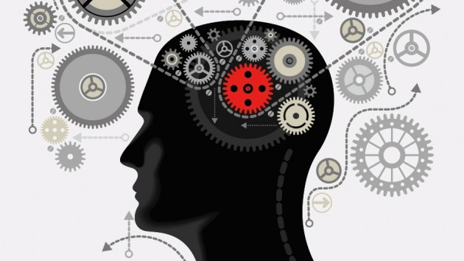

Prior Learning
- What have you thought about your thoughts yourself previously?
- What do your thoughts feel like as you think them?
- What have you learned from science, religion, English about the nature of thoughts?
- Why is it that we think about the nature of thoughts so rarely?
- Who are you? How do you define who you are?
Background briefing: We think about things – people, ideas, events- all of the time. But we hardly ever think about thoughts themselves. Yet they are the very things we are thinking with. Sometimes it is dizzying to do this. But sometimes it is good to turn the telescope around so that it faces back in- instead of looking out at the world, look in at your thoughts.
Many of the philosophers that you can talk about in the conversations from x to y are about our thoughts. However, this is a lighter, more general conversation. Thinking about our thoughts, our mind etc is one of the many branches of ‘Metaphysics’ – beyond the physical. (the term metaphysics came from the labelling of Aristotle’s books. The first books were about physical laws- ‘Physics’. The other books went ‘beyond Physics’ into other areas- ‘Metaphysics’.)
Discussion.
- Where does a thought come from?
- Where does a thought go when you have finished thinking it?
- Are you made up of your thoughts? Or are thoughts something that happen to you?
- Can thoughts ‘come to you’? Or do you have to think them?
- The philosopher Spinoza thought that people may not think, but instead have thoughts ‘flow through them’. What do you think of this? Is it persuasive?
- Could thoughts be alive if they flowed through people?
- Are your emotions thoughts? Are your emotions made up of thoughts? Or something else?
- Is your personality just made up of thoughts? Or something else?
- How are your thoughts connected to your brain?
- If a large cannonball fell on your head and you stopped thinking forever, would you have died, even if your body was still breathing etc.
- Can a thought be broken up into smaller pieces? Or is a thought the basic unit?
Discuss in groups:
Can you have a thought if you had spent your life alone in a dark, soundproof box all your life?
  - Can you have thoughts if you have nothing to have a thought about?
  - Could you have a thought about darknesss if you had never seen light?
  - Could you have a thought about yourself if you had never met anyone else?

TOPIC: WHO DO YOU THINK YOU ARE?
Lesson 2 +3
When is you not you?
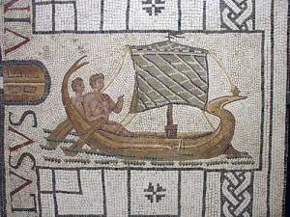
Background Briefing: There is an ancient Greek legend of the Ship of Theseus. This fine and noble ship eventually had all of its oars replaced because they were decaying. Then one by one the planks in the hull of the ship were replaced. Eventually there was no part of the ship that was made of the same material. Philosophers such as Plutarch then asked ‘was it the same ship?’ There are less ancient examples of this same paradox, from John Locke’s sock (if he kept patching up holes with new wool until none of the old sock was left - is it the same sock?) to George Washington’s axe (the head was replaced, then later the handle was replaced- is it the same axe?)
Discuss (in pairs, groups, class or combination)
- When is your old House not your house?
  - If you got new armchairs in your house, is it the same house?
  - If you renovated the kitchen in your house, is it the same house?
  - If you changed all the furniture in your house, is it the same house?
  - If you changed the roof on your house is it the same house?
  - If you got a renovation on your house, is it the same house?
  - If you replaced all of the bricks in your house. Is it the same house?
  - If you did all of these things to your house, is it the same house?
  - If the builder who made your new house stole all of the old throwaway items and put them together in the same way on a block of land a suburb away, is this really your house?
  - When does something stop being the same house and start being a different house?

More background briefing: Your cells change. Some of the cells in your stomach last only a few days. The surface layer of your skin lasts about two weeks before it is replaced. A red blood cell lasts about three months and cells in organs such as the liver last about a year or two. Bones are gradually replaced so that all the cells are new every ten years or so (not all at once- a few every day, so that very few cells are there for more than ten years) Some muscle cells around the ribs can last fifteen years.
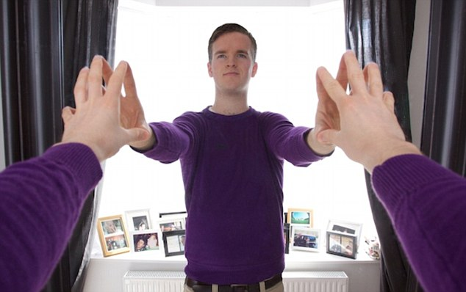
Discussion:
- Will you have the same body in ten years time that you have today or not?
- Is it the physical cells or the ‘recipe book’ (the DNA instructions) that define your body?
- Why are you the same person that you were last year?
- If you learn a whole lot of new Maths tomorrow will you be the same person as you are today? Why?
- If you convert to a different religion tomorrow will you be the same peron in a year as you are today? Why?
- If you lose your legs tomorrow, will you be the same person in a year as you are today? Why?
- If you change your mind about a big issue (e.g you decide to vote Republican instead of Democrat/Liberal instead of Labor) are you still the same person? Why?
- Do any/all of the following things keep you as the same person:
  - Your memories
  - Your soul
  - Your consciousness
  - Your attitudes
More meat: A number of philosophers such as Plato and Descartes (1596-1650) held that it is the soul that keeps someone’s identity together. John Locke (1632-1704) on the other hand held that it was someone’s ‘consciousness’ that held them together from year to year. People’s thoughts and beliefs could change, but their consciousness would remain the same.
David Hume (1711-1776) had a more radical suggestion. He thought that personal identity (or your ego) was an illusion. If he had lived in the twentieth century, he probably would have thought that your ego was like a movie. A ‘movie’ is just a set of separate still images on a movie reel. However, when played very fast one after the other, they all create the impression that there is a single moving image- the film. So too he thought that the ego was just a set of sense impressions from the world played one after the other. Together they create a sense of personal identity, but this is an illusion.
Write in your cornerstone journal
- What Decartes and Hobbes though about each person’s identity.
- What you think about these ideas.
- What you learned/thought about as a result of your discussions

Discussion Acitivity: More ‘when do you stop being you?’
Get one person in each group to cut up each of these scenarios in and put them into a (proverbial) hat. Then work in groups and pull them out one by one. Discuss each of them for three minutes. Then rank them all from ‘Most like you’ to ‘least like you’
- If your favourite food changed from ice-cream to sushi, would you still be you?
- If you had all of your memories wiped, and then replaced with all of the memories, personality etc of another person called Chris, would you still be you? Why?
- If you suddenly hated all of your favourite foods, and liked every food you used to hate, would you still be you?
- If you started losing your memories, so that you thought that the woman down the street was your mother and the boy at the newsagent was your brother, would you still be you?
- If a brick fell on your head and your personality changed so that you were much more angry, frustrated and negative that you are now, would you still be you? Why?
- If a second passes and you have a new thought, would you still be you?
- If you have a sleeping dream that you are a warrior fighting dinosaurs.At that moment, are you you?
- Imagine that between the ages of eight and ten you fell into a deep sleep that no-one could get you out of. You then wake up. Years later, scientists replace the ‘lost’ two years with memories of you taking a wonderful trip around the world. These memories feel incredibly real. Would you still be you?

- What is you? What makes you you from one year to the next? How do the Philosophers that you briefly looked at help you here?

TOPIC: WHO DO YOU THINK YOU ARE?
Lesson 4
Copying you….
Imagine that an enormously powerful computer in your bedroom could store everything about you- your memories, your emotions and your genes. Imagine also that you had a very powerful 3D Printer in your bedroom that could reprint your body, cell for cell, atom for atom. This 3D Printer can also download all of your emotions and memories from the computer into this reprint. You print out a copy of yourself to go to School so that you can stay at home and watch Youtube or play some games.
Discuss, in a combination of pairs, group and whole class:
- Does the reprinted copy of you think it is you?
- How would it feel to be the reprinted copy?
- Would the clone feel that it had just been copied, or would it think that it had had a whole life (using your memories).
- If the computer had scanned all of your memories, thoughts, brain positions and atoms, has it scanned all of you?
- Do you think you would get on with the reprinted copy of you? Do you think you could become friends?
- If the reprinted copy of you went to School and had different experiences to you, would it still be you? If it kept going to school and playing with your friends while you stayed in your bedroom would it be MORE you than you?
- Imagine your Mum came into the room and the clone said ‘Hi Mum, I’M your real child, and that other body was just printed out’. How would you be able to prove that you were the original you? How would your Mum be able to tell the difference? Would she be able to love both the clone and you equally?
- If you suddenly fell out of your bedroom window and died, would ‘you’ still be alive because the clone existed?
- Is the clone you? Are there two you’s now?
- Does the clone have rights?
- Imagine that the 3D Printer malfunctioned so that instead of making one copy of you it made four. Are all of these copies you? Do they all feel like they are you?

Write into your cornerstone journal:
- Imagine that the computer with all of your memories etc stores all of this information on the web. The owner of a huge cotton farm downloads this information and with a 3D Printer of her own and a makes a thousand copies of you. She then puts them all to work on the cotton farm. Would all of these people think they were you? Are they real people? If your Mum turned up at this cotton farm, would they all think that this really WAS their Mum?
- Do you think these 1000 clones of you would be able to band together to break out of the cotton farm? Would they all want to lead? Would they all want to follow?
- Imagine that you need a heart transplant. Would it be okay to use the 3D Printer to make a copy of yourself and take that heart two minutes later?
- What did I learn from this discussion?

TOPIC: WHO DO YOU THINK YOU ARE?
Lesson 5
The mind swap.
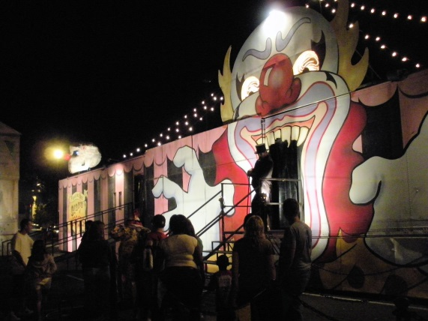
Activity:
Get two people up to the front of the class to act the roles of Bob and Ferdinand in the following scenario. The teacher can be the Great Mephisto.
Imagine…. Imagine two boys, Bob and Ferdinand, who each go to the circus and visit ‘The Amazing Mephisto’s’ booth. The Amazing Mephisto offers them ‘The Swap of a Lifetime’- sight unseen. They agree. Each of them walk into a darkened booth. On the other side they can just see about twenty people in an audience watching. Each of them feels something tingly and strange on the top of their heads….
The audience gasps. For the Great Mephisto is draining each of their minds. Everything in each of their minds is trickling into two bottles that the Great Mephisto is dangling over their heads.
Then the audience gasps again. For the Great Mephisto has now swapped the bottles around and is pouring the thoughts back in! But she is pouring Bob’s mind into Ferdinand’s body and Ferdinand’s mind into Bob’s body!!
Each head blinks. Each body starts to move. But who is who?

Write up on the board:
Person 1 Person 2
(Ben’s body, Ferdinand’s mind) (Ferdinand’s body, Ben’s mind)
And get each student to stand underneath either ‘Person 1’ or ‘Person 2’
- The Great Mephisto knows that Ben loved Sushi before and Ferdinand hated it. He offers them both some sushi. Who takes it- Person 1 or Person 2?
- The Great Mephisto knows that Ferdinand was a great runner before and Ben was terrible. He makes them run a race. Who wins, Person 1 or Person 2?
- The Great Mephisto knows that Ben was excellent at Maths problems before and Ferdinand was terrible. He sets them both a Maths quiz. Who wins it, Person 1 or Person 2?
- The Great Mephisto gets each of them to go to their mothers. Who goes to who?
- When Person 1 has a new thought, whose thought is it? A Ben thought or a Ferdinand thought?
- Where do your thoughts end and your brain begin?
Who is who? Is there a Ben in a Ferdinand body, or are there two entirely new people at the circus

TOPIC: WHO DO YOU THINK YOU ARE?
Lessons 6+7
Memories and Forgetting.
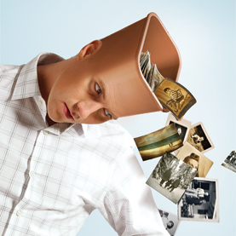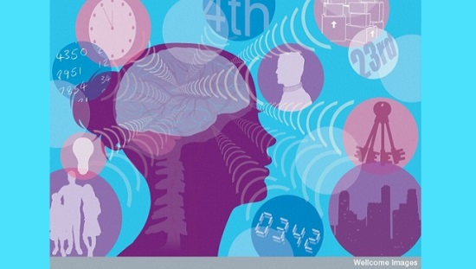
Write in your cornerstone journal:
- What is a memory?
- How long after something happens does it become a memory to you? Five seconds? An hour? A year?
- Where do memories go in your head?
Discussion
- If you forget something, where has the memory gone? What has happened in your brain?
- If you remember something (e.g a password to an internet site) after trying to remember it for days, where has it been in the meantime? Was it forgotten?
- If a smell or a glance at something makes someone suddenly remember something they did twenty years ago but hadn’t thought about since, where have these memories been? Were they forgotten?
- Is anything ever forgotten, or is it waiting in your brain to be retrieved?
- Some people have a condition where they are unable to make new memories. Can you describe what life would be like for these people?
- Some people have ‘photographic memories’ where they remember everything they see or read. What would life be like for these people? Could there be anything wrong with it?
- If you read a book and completely forget about it a year later, was reading it a waste of time? Why/why not?
- Is it more important to experience something or remember it?
- Some people say they have forgotten everything that they learned at school. Have they really? Does this make school a waste of time for them?

More meat. Philosophers have generally agreed on different types of long term memory:
Procedural memory- such as knowing how to hammer a nail or play a piano
Semantic memory- which is memory for facts and ideas from the world, such as Bill Clinton being President of the United States from 1992-2000.
Episodic memory- such as recalling last year’s Christmas Day, or your first day at school.
John Locke has written about the role of memory in creating a personal identity. Everything else changes over time, but your memories persist and are an important part of making you ‘you’ from one year to the next.
Anne Wilson and Michael Ross (2003) have been very interested in autobiographical memories- memories of your own past. They state that people have a strong idea about the type of person that they are and then they partly adjust their personal memories to fit that sense of themselves. (This is the reverse of the usual notion that your accurate memories tell you what type of person you are). Indeed, they say that if you change your self perception, you unconsciously go back and alter your memories to ‘fix’ this.
Activity
- In your cornerstone journal write some core memories that create the ‘narrative’ of you and tell you what sort of person you are. Perhaps they are experiences from a holiday, or from childhood.
- Could you have shaped these memories to fit the sort of person you think you are? Or are they accurate?
- Discuss this with the person next to you.
Discussion
- Do your memories help create you, as John Locke would state? If you had all of your memories wiped would you still be you?
- Do people really change your memories to fit your sense of themselves? Can you think of an example? If you went from thinking you were pretty good at tests to thinking you were pretty bad at tests, what memories of yours could change as a result?
- Imagine that you forget being lost in the shopping mall as a small child. Your mother or father reminds you of this ten years later and you resconstruct it. Is this a real memory?
- If someone offered you the chance to ‘upload’ a whole lot of false memories about going to Disneyland and having a fantastic time, would you take it?
- Some people create false memories of complete childhood incidents that never happened. Why would they do this? How could it happen?

Extension Activity
- Read the following two pieces about Memory and John Locke:
  - http://plato.stanford.edu/entries/memory/
  - http://www.studentpulse.com/articles/275/the-lockean-memory-theory-of-personal-identity-definition-objection-response
  - See if you can use them to come up with 400 words about what John Locke thought about memory.

TOPIC: WHO DO YOU THINK YOU ARE?
Lessons 8+9
All About Your Thoughts (Part Two)
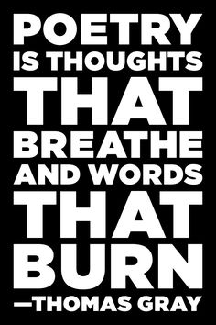
Activity
- In your cornerstone journal write two poems that reflect the thoughts that you had about thoughts. See if they can encapsulate some of the ideas in the discussions that you had.
- Get together in groups of four.
- Choose two of the groups poems, and choose two short poems that you have found on the internet or as a result of your studies in English.
- Put them together in a group of four.
- Give the four poems to another group. The other group have to work out which two poems are by your group and which two are poems available on the net.
- At the same time another group will give you four of their poems and you have to work out which two were written by them.
Discussion
- Do your thoughts make up who ‘you’ are. Or does something else?
- If you really love someone, are your thoughts in love as well? Can thoughts be in love?
- If your mother tells you a thought (e.g Earth is the third planet from the sun) and then you have it
  - is your thought the same as her’s?
  - Is it a copy of her’s?
  - Is it identical to her’s.
  - What if the thought was ‘it’s a nice day today’ instead?
- If you have lots of good thoughts, but don’t act on them, does this make you a good person?
- Can thoughts ever be visible?
- Electro-scanners have pictured electrical activity in the brain when people think.
  - Does this mean that thoughts are a type of electricity?
  - Is this all thoughts are?
- Imagine a fun park ride you have been looking forward to for months- the wildest most extreme roller coaster ride. Can your thoughts of this ride be actually better than doing this ride? Think about
  - Your anticipation in the weeks before
  - Your memories in the weeks after
- What are the differences between the following types of thinking. Which ones do you like doing the most? The least?
  - Imagining
  - Wondering
  - Remembering
  - Anticipating
  - Fearing
  - Re-evaluating
- Think about the thoughts you have in your sleep. Are these different to day time thoughts? Why/why not?
- Think about the thoughts you have about thinking. Are these different to regular thoughts? Why/why not?
- Can you think without words? Can a child who is brought up in the woods by mute wolves think?
- Can dogs think? Can fish? Can oysters?
Write in your cornerstone journal:
- When a computer beats you in chess is it thinking?
- Can the most powerful computer in the world think?
- How could you tell if a computer was thinking for itself.
- Can you imagine a time in the future where computers can think for themselves?
  - Would we have then made a new species?
  - Would we have to look after this new species?
  - Would this new species dominate us?

  - Do thoughts feel like electricity? What do thoughts feel like (what does electricity feel like?)

- Just imagine that all of the people and animals in the world suddenly vanish. Are there any thoughts left on the planet?
  - In books?
  - In computers?
  - In the results of people’s thoughts (e.g inventions such as cars)
Can there be thoughts at all if there is no-one to think them?
- What has the discussions in the unit led to you to think about your own thoughts, personality, memory and identity?
Extension
- Draw up a list of novels and films that you have read/watched that include philosophical issues of memory, thoughts, cloning etc.
- Rank then into your top three.
- Share these with others in the class and make up a whole class list.
- Publish this list on Pininterest or another website.

Summative Assessment.
In English you have been doing Poetry and Memory.
Write a creative piece- poetry, a radio script or a short story- that captures as many of the ideas about identity, thought and thinking as you can.
You will be assessed on
- The quality of the ideas that you are able to express in your writing.
- The way in which the ideas in your writing reflect the discussions that you have been having in your class.
- An engaging story that is well written and holds the marker’s attention.
Lesson Six: Invention and Discovery
- Discussion on The Ship of Theseus and when any thing becomes something else.
- Brief introduction to philosophical viewpoints about Identity from David Hume (paradox of continuity and change).
- Reflection in journal about identity.

Lesson Seven: Copying You.
- Hypothetical Activity about a futuristic copying machine.
- Discussion on the nature of cloning and the nature of each individual produced.
- Activity: Working competitively and co-operatively as a group.

